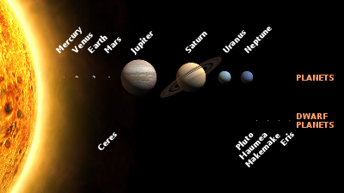 Key features of planets in comparison with the Earth

Solar System | Names of planets  in English | Diameter  in comparison with the Earth | Mass  in comparison with the Earth | Orbital radius,  а. е. | Period of revolution, years | Satellites | Names of Satellites
Солнце | Sun | 109 | 333000 | - | - |  | 8 planets
Меркурий |  | 0,382 |  |  | 0,241 | -
Венера |  |  | 0,82
Земля | Earth | 1 | 1 | 1 | 1 | 1
Луна | Moon | 0.27 | 0.012 | 384,000 km | 29.5 days | -
Марс |  |  |  | 1,52
Юпитер |  | 11,2 |  |  | 11,86 |  | Ganymede, Callisto, Io, Europa
Сатурн |  |  |  |  | 29,46
Уран |  |  | 14,6
Нептун |  |  |  | 30,06

http://en.wikipedia.org/wiki/Solar_System

